**Worksheet- 3**

**Student Name:-** Pushpraj Roy **UID:-** 20BCS9866

**Branch:-** BE- CSE **Section/Group:-** WM_617 “A”

**Subjetct Code:-** 20CSP-312 **Semester:-** 5th

**Subject Name:-** DAA Lab

1. **Aim/Overview of the practical: -**

Code to find frequency of elements in a given array in O(n) time complexity.

# Task to be done/ Which logistics used :-

To find the frequency of element in array using for loop.

1. **Algorithm/Flowchart :-**

Step 1- Let us make an array of size n taken by user.

Step 2- Put the values in it.

Step 3- Make a variable freq=1 and idx=1 and element=arr[0].

Step 4- Now run a while loop to compare arr[idx-1] with arr[idx] if they are equal then increment of freq and ldx by 1 is there else print frequency of the element..

Step 5- Run the while loop till idx < n.

1. **Steps for experiment/practical/Code :-**

#include <iostream>

using namespace std;

int main()

{ int n;

cout<<"Enter the length of array: "<<endl;

cin>>n;

int arr[n];

for(int i=0;i<n;i++)

{

cout<<"Enter the element of array: "<<endl;

cin>>arr[i];

}

int freq = 1;

int idx = 1;

int element = arr[0];

while (idx < n)

{

if (arr[idx - 1] == arr[idx])

{ freq++; idx++; } else

{

cout << element << " frequency of an element is: " << freq << endl; element = arr[idx];

idx++;

freq = 1;

}

}

cout << element << "frequency of an element is: " << freq <<endl; }

1. **Result/Output :-**

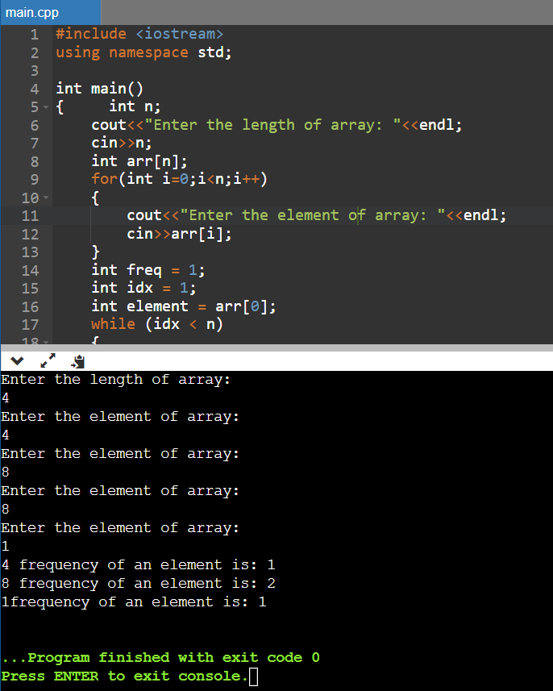

1. **Learning outcomes (What I have learnt):**

* To learn how to calculate the frequency of the elements of an array.
* To learn how to use for loop in these cases.

**Evaluation Grid (To be created as per the SOP and Assessment guidelines by the faculty):**

|  |  |  |  |
| --- | --- | --- | --- |
| Sr. No. | Parameters | Marks Obtained | Maximum Marks |
| 1. |  |  |  |
| 2. |  |  |  |
| 3. |  |  |  |
|  |  |  |  |